Debt Elimination Worksheet

Identify your debts, and record them on the Debt-elimination Worksheet below (you can go to https://doctorace.com/resources/ and download the worksheet). First, pay all small debts (less than $10,000) starting with the smallest. This “small debt” category includes credit card debt, consumer debt, auto loan balances and small student loans. Start with the smallest debt (no matter how high or low the interest), and then use the money from your debt-reduction savings account to pay it off first, while continuing to make the minimum payments on your other debts.

At the beginning, it’s important to get momentum and see that you are making progress, so don’t worry about the respective interest rates now. If the high credit card interest rate on a larger debt bothers you, you can always call the company and successfully negotiate a lower rate or transfer your balance to another credit card company with a lower rate.

Once you have paid off the first debt, you’ll feel a sense of empowerment. Paying off that debt frees up additional money, which you add to your savings. Use this increased savings to pay down the next-smallest debt. Fill out the worksheet in pencil so that you can update it each month. This will help you keep on track and stay motivated.
As you pay down debt, you gain momentum and free up more money to pay off the next debt. The money that pays off these debts comes from increased income, reduced spending, and the extra money that becomes available as you pay off each debt. If you have money saved when you begin setting in motion Dr. Ace’s Financial Freedom Guide, for the sake of your peace of mind, do not use that money for early debt reduction for at least six months. Below is an example of how we pay off debt.

First, determine what percentage of income you want to pay toward debt. If you and your spouse’s average income is $72,000, you would divide this by 12 months, giving you $6,000; after taxes, that would be $5,000. 10% of this would be $500 per month.

The $500 (10%) will be paid each month to the principal of the top loan in the chart. First, add the $500 to the Visa card $30 payment, giving you $530 per month to pay toward that loan, which will be paid off in two months. When the Visa card is paid off, apply that $530 plus $32 to the next MasterCard loan, which will result in $562; it will take three months to pay off that loan. Your efforts will continue to eliminate all your debt. The debts will be paid off in seven years and four months, and you will have an extra $31,176 per year to invest, save, take vacations, send children through college or work less.
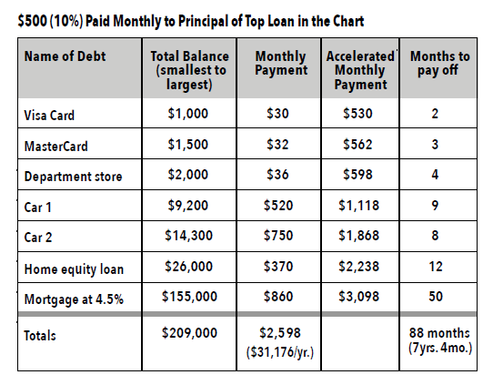
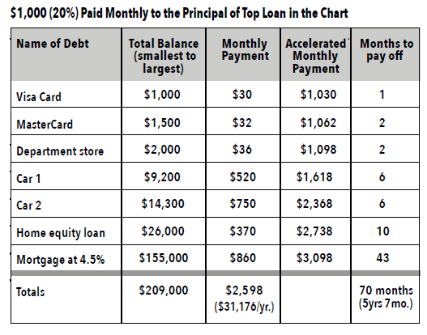

Your Debt-elimination Worksheet: Calculate Paying Off Your Debt

Annual household income: $ ________ )
(Average American debt is 2.5 times the annual household income)
1. Determine your extra monthly payments: $
Try for 10% or more of your monthly take-home income. If you have only a home mortgage, then you should add 20% to 30% of your monthly take-home income.
2. Write down each debt in the first column below, prioritizing each debt from smallest to largest. Do not be concerned about the interest rate.
3. Using the debt-elimination approach, add your accelerator margin to the smallest debt, making this new monthly payment. Put this in column 4. To determine when the debt will be paid off, divide this amount into the total balance of that debt by the new monthly payment in column 4, and put the number of months to pay off in column 5.
4. When this debt is paid off, add what used to be the monthly payment amount to the next smallest debt payment, and place that in column 4. Again, divide this amount into the total balance of that debt by your new monthly payment in column 4. Put the number of months to pay off in column 5.
5. Continue adding each paid-off debt’s monthly payment amount to its accelerated monthly payment and rolling the total amount to the next debt.
6. Add up the months in column 5 to determine when all debts will be paid off.

Name of Debt | Total Balance | Monthly Payment | Accelerated Monthly Payment | Months to Pay Off
1 | 2 | 3 | 4 | 5
Totals

Things to keep in mind about your debt-elimination plan:
- Use only minimum payments to maximize the debt-elimination process.
- Use only the principal and interest portion of your mortgage payment (not tax/insurance).
- Interest rates are not a big factor.
- Only non-recurring debts go into your debt-elimination plan.

